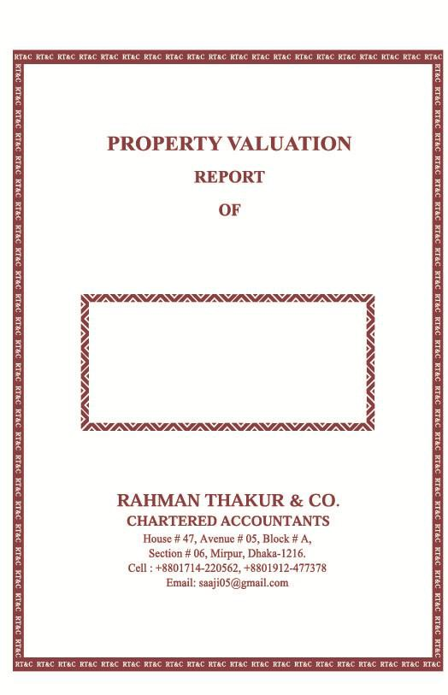

SULTANA NASRIN
AS ON May 20, 2026
TABLE OF CONTENTS

SI# | Particulars | Page
1 | Valuation Report | Page -1
2 | Annexure-I: Details of Immovable Assets | Page-2
3 | Annexure-11: Details of Movable Assets | Page-3

RAHMAN THAKUR & CO.
Chartered Accountants
RT&C

Section# 06, Block# A, Avenue#05 House# 47, Mirpur, Dhaka- 1216.
Phone - +880 248 031 993
Mobile-+880 1714-220562
+8801912-477378
e-mail: saaii05@gmail.com

VALUATION REPORT

TO WHOM IT MAY CONCERN

This certificate has been issued on the request of SULTANA NASRIN, (Address: Village: Char Ramiz, Post Office: Bibir Hat-3732, Ramgati, Lakshmipur, Bangladesh) for valuation of their properties.

Please find attached valuation report of the property owned by SULTANA NASRIN, which is based on documents furnished by client and carried out at prevailing market rate.

With the respect of the statements, we also report that:

- We have obtained all the information and explanations which to the best of our knowledge and belief were necessary for the purpose of our NZD it and made due verification thereof;
in our opinion, the annexed Valuation Report have been drawn up in conformity with the Bankruptcy

Act, 1997;
and the Valuation Report exhibits a true & fair view of the state of affairs of the persons according to the best of our information and explanations given to us and as shown by vouchers and related documents.

And certify that they currently have the following monetary value of their assets:

S.L. | Property Name | Amount in BDT | Amount in NZD $
A. | Immovable Assets | 16,900,000.00 | 234,852.69
B. | Movable (Liquid) Assets | 6,000,000.00 | 83,379.65
 | Total | 22,900,000.00 | 318,232.35

In Words (BDT): Two Crore Twenty Nine Lac Bangladeshi Taka Only.

In Words (NZD $): Three Hundred Eighteen Thousand and Two Hundred Thirty Two New Zealand Dollars and Thirty Five Cents Only.

N.B: NZD $ 1.00 = BD Tk. 71.96 (Approx.) Details are shown in annexure.

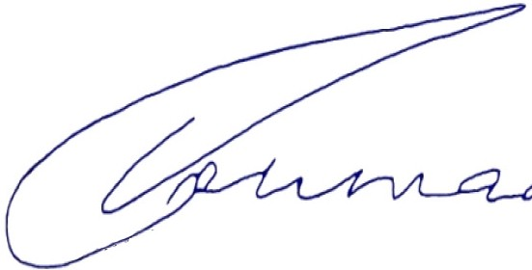
Dated : May 20, 2026

Place : Dhaka

(Md. Waliur Rahman Thakur FCA) Rahman Thakur & Co. Chartered Accountants
Page-01

Rahman Thakur & Co.
Chartered Accountants. Section-06, Block-A, Avenue-OS, House-47, Mirpur, Dhaka-1216.

VALUATION DETAILS OF

SULTANA NASRIN

- VALUATION OF IMMOVABLE ASSETS: Annexure-I

SL. NO | DESCRIPTION | MARKET VALUE  (Approx.) BDT | MARKET VALUE  (Approx.) NZD
1 | Land:  That SULTANA NASRIN is the owner of following Total area: $4\frac{1}{2}$ (Four and a half) decimals Land at Dist- Noakhali, P.S: Noakhali Sadar, Mouza: 95 No Krishnorampur, Mutation Khatian No. 1975 and Deed No- 12305, Date: 15/12/2019. | 85,00,000.00 | 118,121.17
2 | Land:  That SULTANA NASRIN is the owner of following Total area: $4\frac{1}{2}$ (Four and a half) decimals Land at Dist- Noakhali, P.S: Noakhali Sadar, Mouza: 95 No Krishnorampur, Mutation Khatian No. 1697 and Deed No- 254, Date: 16/01/2017. | 84,00,000.00 | 116,731.51
A) | Total Immovable Assets | 16,900,000.00 | 234,852.69



"(Md. Waliur Rahman Thakur FCA)

(Md. Waliur Rahman Thakur FCA)
Rahman Thakur & Co.
Chartered Accountants

Page- 02



Rahman Thakur & Co.
Chartered Accountants. Section-06, Block-A, Avenue-OS, House-47, Mirpur, Dhaka-1216.

- VALUATION OF MOVABLE ASSETS: Annexure-11

1.00 Fixed Deposit Receipts (FDR):

That SULTANA NASRIN has been maintaining 01 (One) Fixed Deposit Receipts (FDR) Account at PUBALI BANK PLC, bearing account numbers are as follows and the present working balance is:

SL.NO | Description | AMOUNT IN  BDT | NZD $
i) | FDR A/C No- 2966172381112, Issue date: 12/01/2025 | 6,000,000.00 | 83,379.65
B) | Total Movable Asset | 6,000,000.00 | 83,379.65

The person mentioned above regarding ownership of Land, Tangible Assets and Bank FDR (Liquid) Assets are quoted based on the deed of agreement and other relevant documents / papers submitted to us by SULTANA NASRIN.


N.B : NZD $ 1.00 = BD Tk. 71.96 (Approx.)

"(Md. Waliur Rahman Thakur FCA)
Source: Bangladesh Bank Website on May 20, 2026.

Dated : May 20, 2026
Place : Dhaka
(Md. Waliur Rahman Thakur FCA)
Rahman Thakur & Co.
Chartered Accountants

Page- 03



